y

Registration Form
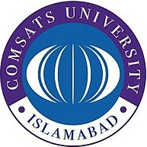
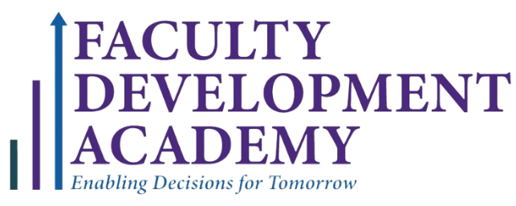
COMSATS UNIVERSITY ISLAMABAD
FACULTY DEVELOPMENT ACADEMY

Professional Certificate in Applied HR Management
August 1 – October 5, 2025

Name: |  | Designation:

Organization/ Department: |  | Educational Qualification:

Postal Address:
Cell No: |  |  | E- mail: |  | CNIC No:
Payment Details: Deposit slip No. / Transaction ID.

Participant’s Signature ……………………………….

Faculty Development Academy

4th Floor, Faculty Block-II, COMSATS University
Park Road, Islamabad
Email: ishtiaq@comsats.edu.pk
Cell:0333-5116800
Ph # 051-90495446

